**CSE 587 | Data Intensive Computing**

**Project – Phase 3**

Prashant Godhwani

Akhilesh Goriparthi

**Problem Statement**

With more and more places to eat being opened every day, people want to make informed decisions and have a good experience when they do choose a restaurant. Yelp, an open crowd-source platform, contains information about restaurants including but not limited to reviews, categories, locations and other relevant features that can be leveraged to recommend users places to eat based on their preferences. The challenge is how to use this big data to make reasonable inferences and model it to build a recommendation system that can save people the hassle and energy while ensuring a better experience.

**Link to Dataset -** <https://www.yelp.com/dataset>

**Our Solution | UB Recommends**

UB Recommends is our answer to recommending right to you. Our product takes into consideration a wide plethora of features to make recommendations based on your past preferences and using reviews from millions of users across the United States. The product deals with problem of cold start, by giving new users to options to select the cuisines they are interested in, and then recommend by giving them 2 options - Top Notch, and Explore the Beyond.

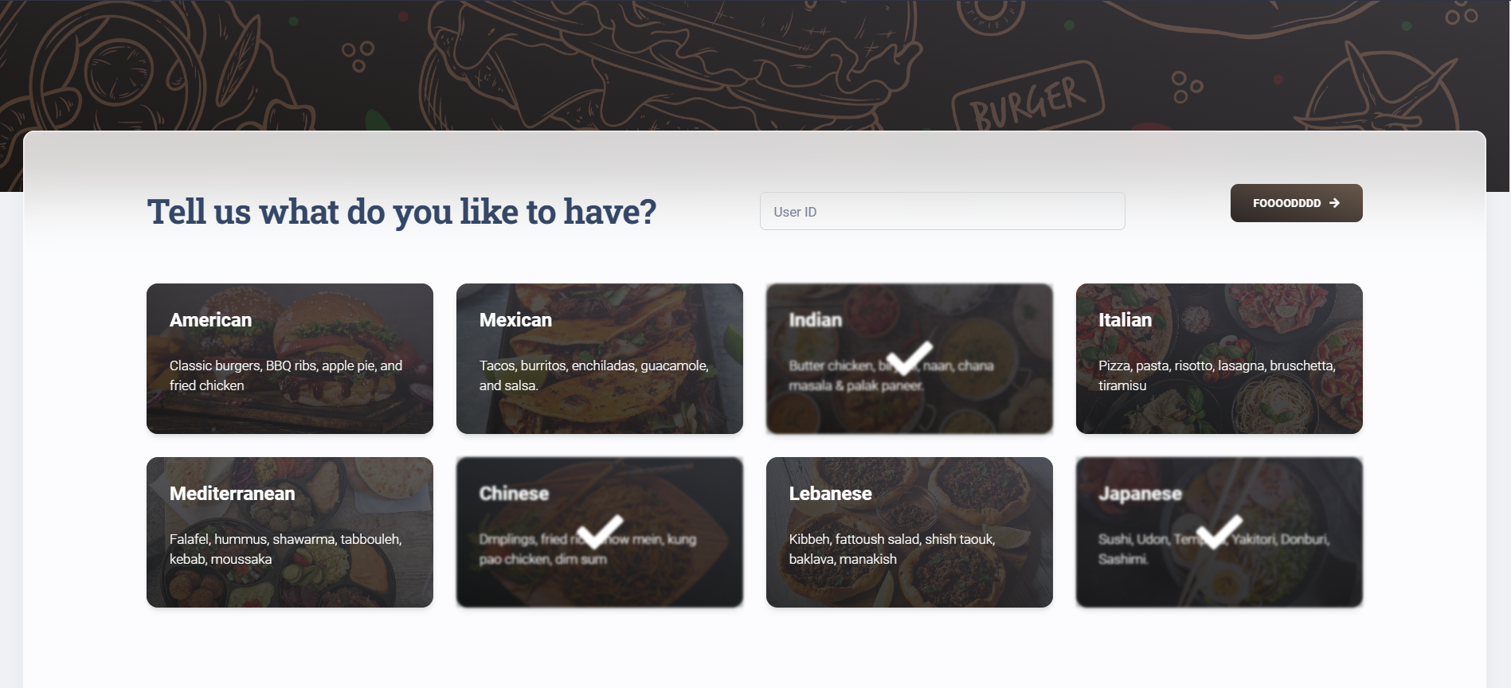

Once the User Logs in, and if we don’t have their historical data to recommend them new restaurants, we give them top recommendations for the cuisines they selected around their vicinity.

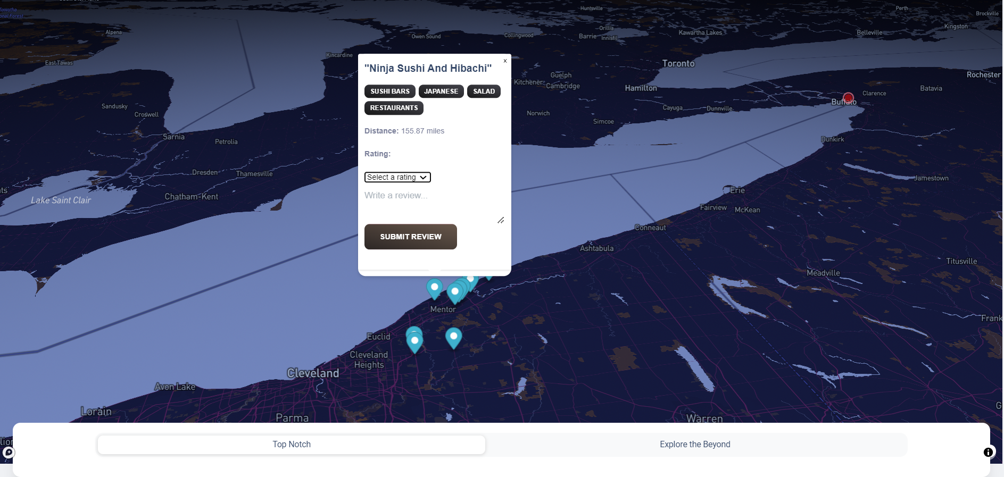

The user can visit these suggested restaurants and leave a rating and review for them, based on which the models can make better recommendations.

UB Recommends with 4 Different Recommendation Modes -

1. **Top Notch -** Top Notch is the most simple and effective way to recommend new and existing users new restaurants to try. For new users, we recommend based on the cuisines they selected giving equal priority to each cuisine in their vicinity. For users that have been using the platform, recommendations are based on the different cuisines they have been trying. We scale the cuisines and average out the ratings given by the user to each restaurant serving a particular cuisine and then recommend.

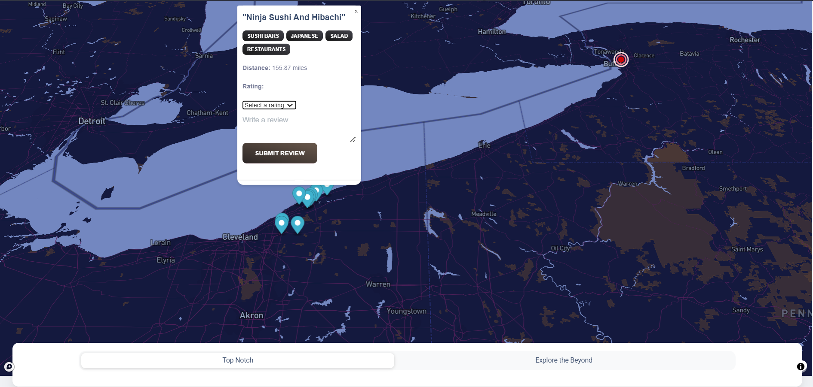

1. **Explore the Beyond** - Explore the Beyond uses our TF-IDF vectorizer model from Phase 2 to make recommendations. We take the search input from the user, check transforms the input text into a TFIDF vector and finds similar businesses using Cosine Similarity. We then finally sort the result based on ratings and recommend to the user. Explore the Beyond doesn’t take into consideration the vicinity of the user and recommends them best restaurants in the country that satisfy what they have been craving for. This also plays well with the limitations of computational resources available to us and the sheer amount of data we have to process and filter to get best restaurants in the vicinity.

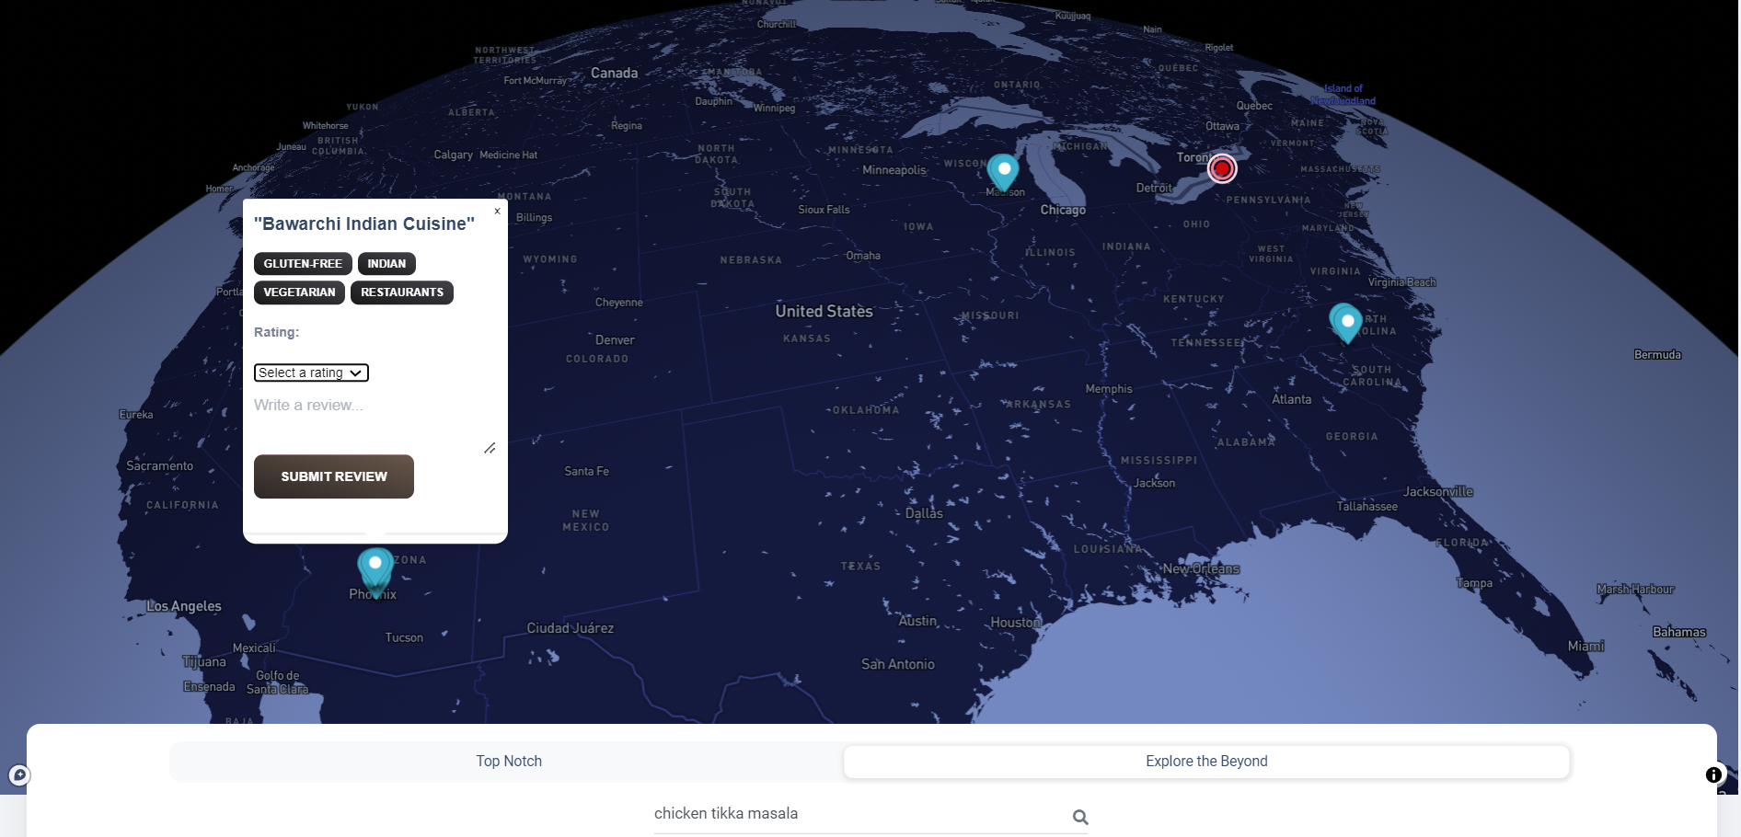

1. **Feeling Lucky -** Feeling Lucky uses the power of Content and Collaborative Filtering techniques in our Hybrid Model from Phase 2. The model takes into account the user preferences from the historical user reviews and restaurant features to find restaurants that are similar to the one’s rated highly by the user and are liked by the user’s with similar preferences as the target user. For every call to this model, we have to train and build the user features and the restaurant features again to fit the model and then make recommendations. In a real world scenario, this training and fitting would be done asynchronously and thus the wait times are way lesser than what you would see at UB Recommends.

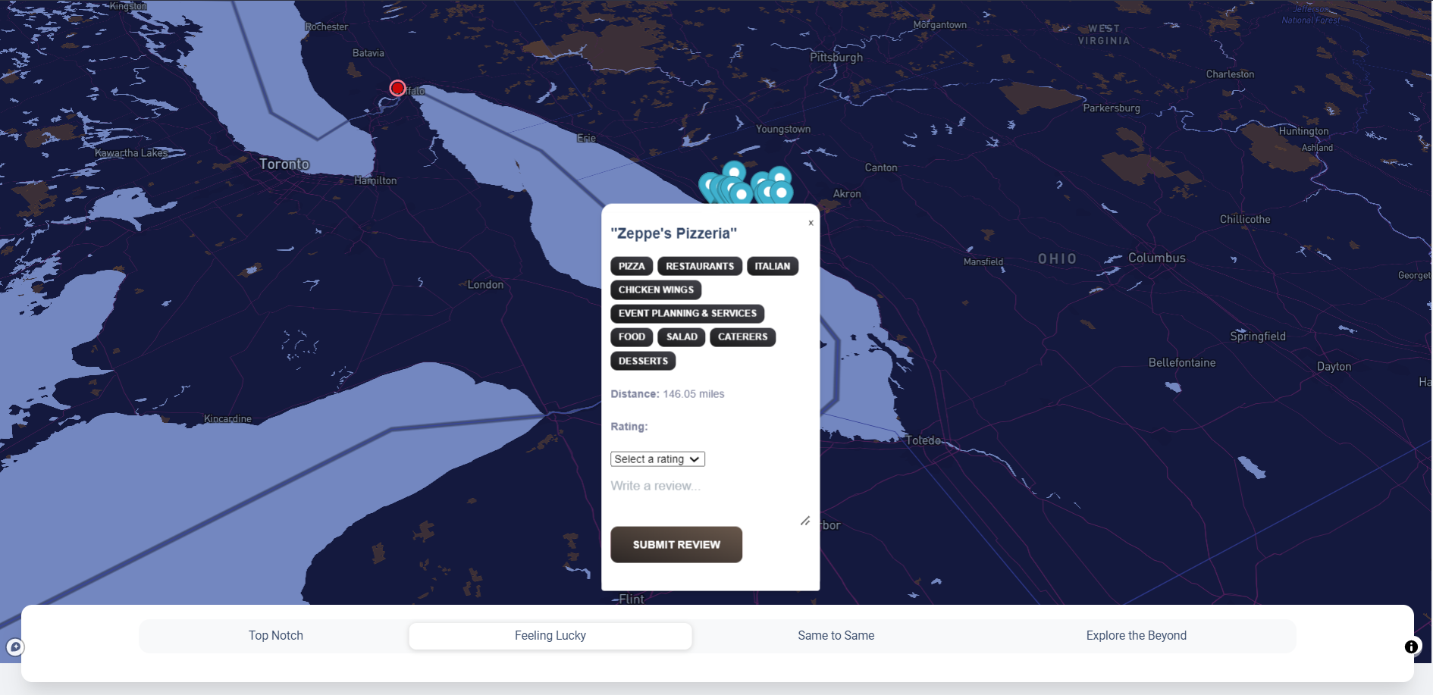

1. **Same to Same -** Same to Same uses the Content Based Model from Phase 2 with cosine similarity, to recommend users restaurants with similar features they have rated highly. The algorithm creates

a TF-IDF matrix taking features (categories, cuisine, review text and stars_scaled(normalized restaurant stars)) and applies Cosine Similarity function to obtain the cosine similarity matrix. This is then used to make recommendations in the user’s vicinity.

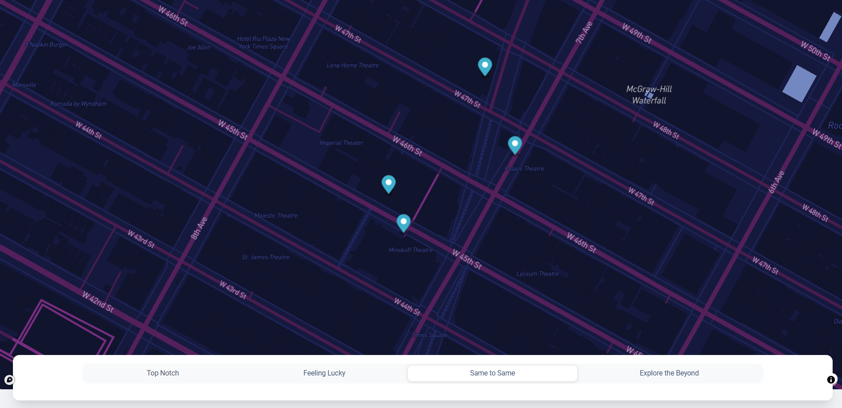

**Setup Environment for UB Recommends**

**Unzip the src/ directory**

The src/ directory contains code for the front-end and the back-end. Start by unzipping the src directory. The back-end code is written in python with django as the framework and the front-end uses vanilla HTML, CSS, Bootstrap and JS.

**Install and setup Python**

This setup guide assumes that python is installed and setup on your system. Please refer to <https://python.land/installing-python> to install python for your machine. Once installed, you can check if your installation was successful by running -

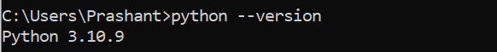

**Running the Front-end**

Running the front-end should be very straightforward. Simply open the directory in any code editor with support of a server for the front-end. We will be using Visual Studio Code with a plugin for the server - Live Server by Ritwik Dey.

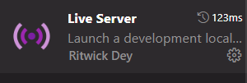

## After the extension is installed all you have to do is open the project and click ***“Go Live”*** on the bottom right.

## This should take you directly to the login screen of UB Recommends.

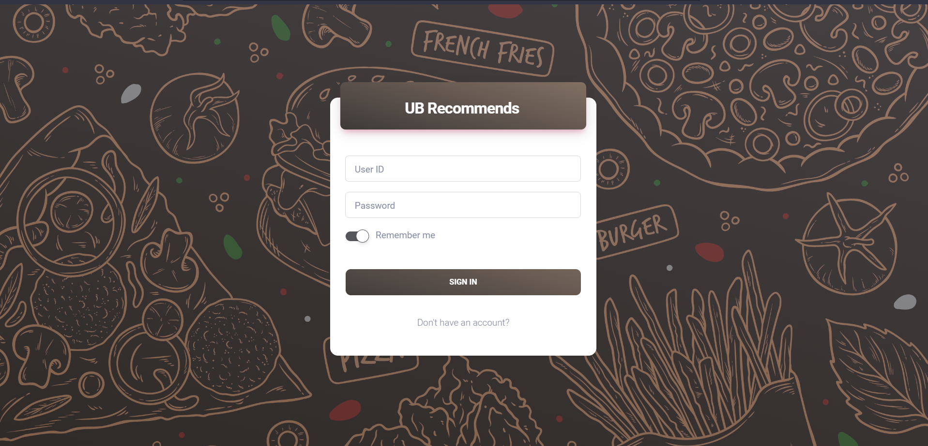

## **Running the Back-end** Running the back-end powered by Django requires a few steps. We start by creating a virtual environment, installing all dependencies, and then running the project. **Create virtual environment** Creating a virtual environment is optional but advisable so that you can setup the dependencies different projects require separately.

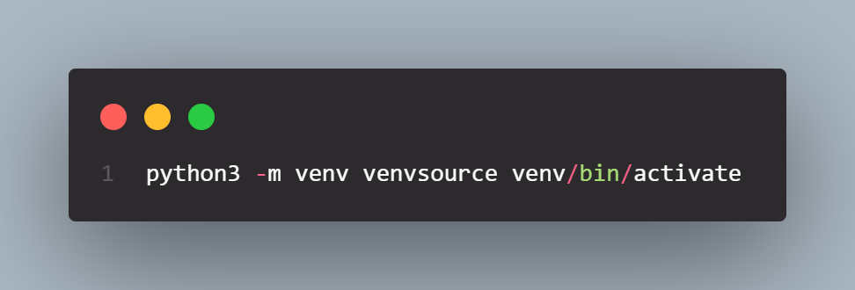

## **Installing all requirements**

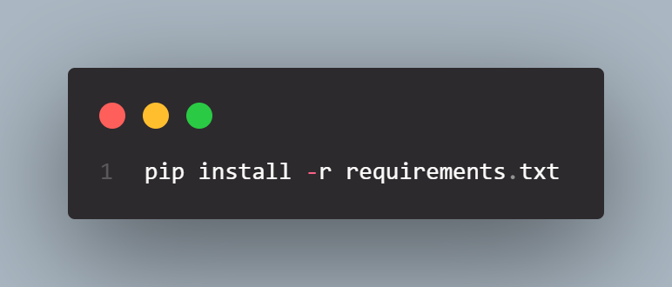

**Boot the Server**

To boot the server, all you have to do is run the below command in the recommendation_system_backend directory, and you will see that the server is up at port 8000.

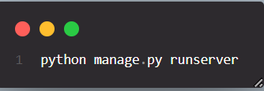

If you see the below logs on the console, it means that the server is up and running.

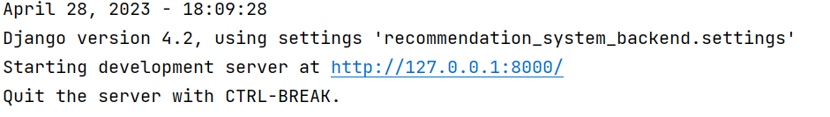

To stop the server, simply press ctrl/cmd + c on the terminal and you are good to go.

**Test UB Recommends**

Testing UB Recommends is as simple is setting it up. You can either test with one of the 10 userIds mentioned below or create a new user, rate restaurants suggested to you *(a significant number for the algorithm to pick your changes)* and see the recommendations with the feedback loop.

user_id review_count

cMEtAiW60I5wE_vLfTxoJQ 380

bLbSNkLggFnqwNNzzq-Ijw 282

DK57YibC5ShBmqQl97CKog 274

d_TBs6J3twMy9GChqUEXkg 254

PKEzKWv_FktMm2mGPjwd0Q 186

QJI9OSEn6ujRCtrX06vs1w 185

S9Jw00eZHVj5_0sOM_C5Rg 161

bpgbVPJcG-wQ4cNBcPPIxw 157

PeLGa5vUR8_mcsn-fn42Jg 154

JaqcCU3nxReTW2cBLHounA    153

The first time you open the application, you will see that the browser will ask for your location, allowing it is necessary as without it some or all of the functionalities may not work as expected.

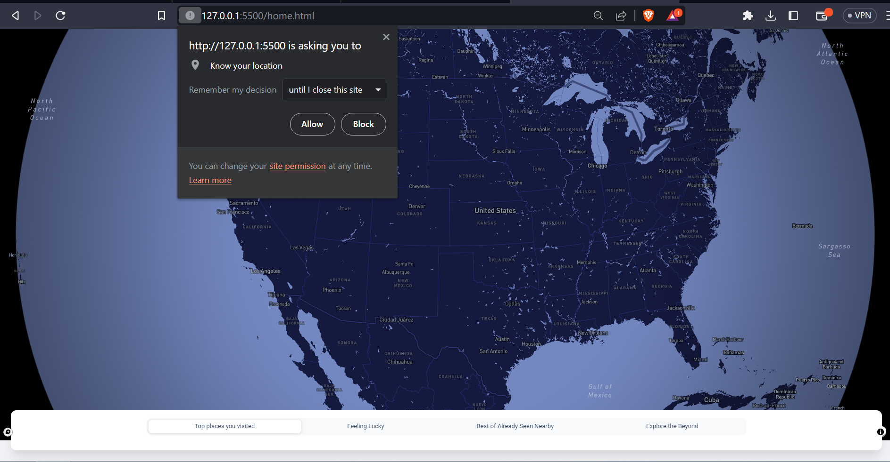

**Models Used for UB Recommends**

We used Hybrid and Content Based models discussed in Phase 2 for all our 4 different classes of Recommendations.

1. **Content Based Filtering with Cosine Similarity and Location Filter**

In this recommendation system, we are recommending restaurants to users that are similar to restaurants that are highly rated by the said user and in user’s geographic vicinity. We started by removing the stop words from the restaurant reviews. What followed was creating a TF-IDF matrix taking features (categories, cuisine, review text and stars_scaled(normalized restaurant stars)) and applying Cosine Similarity function to obtain the cosine similarity matrix.

We then create a function to return top recommendations based on the user_id, and the geographical location of the user (lat, lang), which helps us in returning the restaurants that are most similar to users previously highly rated ones (>=3) in the vicinity.

TBC

**How was the model used**

Due to the time crunch and this being a POC, we used excel sheets instead of actual databases that would be used in a production system. We kept the data in the static folder of Django and served that as a static directory to be used by Django.

Instead of reading the large csv files again and again, we decided the read the csv file when the API call was made and store the corresponding data-frame in cache. This data-frame would then be retrieved from the cache on subsequent calls and recommendations would be made on different inputs.

TBC

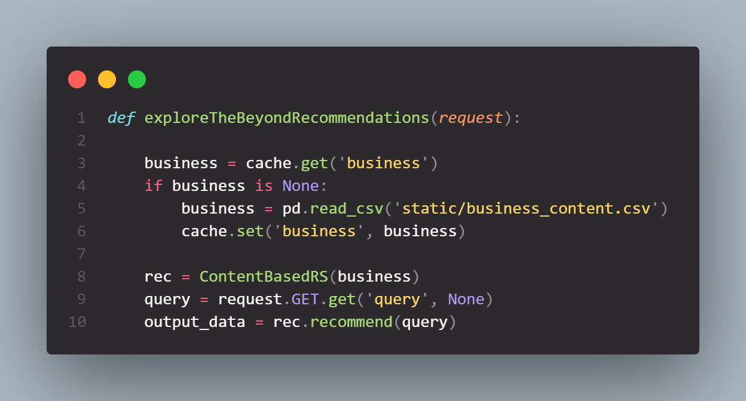

**Tuning of relevant parameters**

We tuned the model in Phase 2 to figure out the best hyper-parameters our model responds to with the data we have, and we use those hyper-parameters - cosine similarity, and restaurant features to make recommendations. One additional thing we do here is to calculate the match score. The match score is the percentage of similarity between the restaurant and your search query.

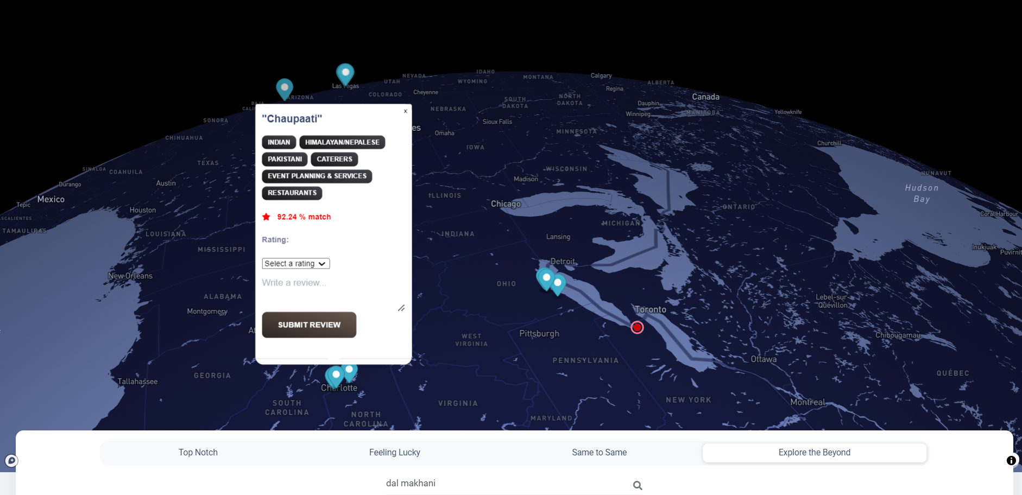

1. **Content Based Filtering with Text Search**

In this recommendation system, we are recommending restaurants to users that are similar to the query passed by the target user. The algorithm transforms the input text into a TFIDF vector and finds similar businesses using Cosine Similarity. We then finally sort the result based on ratings and return the top n restaurants.

**How was the model used**

Due to the time crunch and this being a POC, we used excel sheets instead of actual databases that would be used in a production system. We kept the data in the static folder of Django and served that as a static directory to be used by Django.

Instead of reading the large csv files again and again, we decided the read the csv file when the API call was made and store the corresponding data-frame in cache. This data-frame would then be retrieved from the cache on subsequent calls and recommendations would be made on different inputs.



The model also filters out STOP WORDS using TD-IDF Vectorizer and then uses review text, cuisines, tags to find best restaurants matching the query.

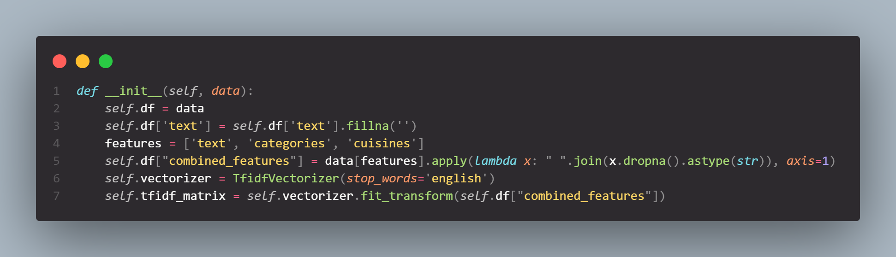

**Tuning of relevant parameters**

We tuned the model in Phase 2 to figure out the best hyper-parameters our model responds to with the data we have, and we use those hyper-parameters - cosine similarity, and restaurant features *(review text, cuisines, tags)* to make recommendations. One additional thing we do here is to calculate the match score. The match score is the percentage of similarity between the restaurant and your search query.



1. **Hybrid Filtering**

The model takes into account the user preferences from the historical user reviews and restaurant features to find restaurants that are similar to the one’s rated highly by the user and are liked by the user’s with similar preferences as the target user. For every call to this model, we have to train and build the user features and the restaurant features again to fit the model and then make recommendations. In a real world scenario, this training and fitting would be done asynchronously and thus the wait times are way lesser than what you would see at UB Recommends.

**How was the model used**

The model takes in the userId and gets the recommendations for a user based on the historical data of the restaurants rated highly by the target user and the restaurants liked by similar user. We cache the initialization of the Hybrid model because it involves reading the large csv files and perform routine cleaning operations on the dataset.

TBC

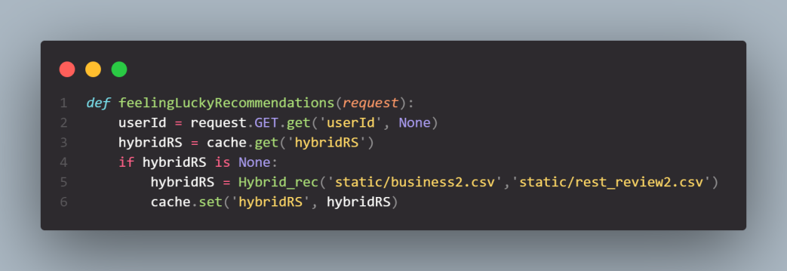

**Tuning of relevant parameters**

TBC

**How does UB Recommends answer the Problem Statement**

**Personalization** - Users get personalized recommendations through the platform based on their past preferences and the community with similar tastes. The 4 different recommendation models help the users discover new dining experiences and make informed choices in their vicinity.

**Exploration -** The *Explore the Beyond* recommendation mode encourages the users to travel across the United States and try highly rated restaurants satisfying their search-query beyond their vicinity. This can help the users get the best of what they want from all across the country and broaden their culinary horizons.

**Similarity based Recommendations -** The *Same to Same* mode helps users discover different restaurants with similar features to the dining options they have previously had great experiences at. This is helpful for users who have a very specific taste or dietary restrictions.

**Different yet Joyful -** The Feeling lucky recommendation mode combines content and collaborative techniques to provide users with recommendations based off their past preferences and the options that users similar to them have enjoyed. This generates to the point but different recommendations that the user may not know about.

**Extending UB Recommends. How?**

UB Recommends can be improved in a lot of ways of which some are mentioned below -

1. **Incorporate Incoming Data** - New restaurants every day in the United States. Currently the application has no way to incorporate this new information and use it to make predictions. Having a mechanism that asynchronously adds and trains the models with the new information will help take new businesses into account and make recommendations.
2. **Real Time Data** - Real time data such as waiting times, if the restaurant is currently closed or open, peak times, special promotions will be a great addition to the platform. This will help the users browse all the information at one place.
3. **Using Better and High end Computation Resources** - We really struggled with the computation resources at our disposal to train the models in real time, incorporate user feedback immediately and run more epochs to better fit the data. Having Better computational resources will help us make UB Recommends incorporate feedback real-time.
4. **Use Databases instead of CSVs** - We currently make use of CSVs to store user feedback which will not scale for multiple users. Usage of a cloud database like Snowflake will better fit the dataset and handle concurrency.
5. **Make Reservations** - We can also add options to make reservations for the restaurants that the users wishes to go to from the platform.
6. **Use Better Algorithms** - We can make use of Deep Learning models and Neural Networks like Autoencoders to make better recommendations. This will help us suggest better restaurants to the users.
7. **Incorporating User Feedback** - We can make use of user interaction with the application by storing it and using it to ask users to rate restaurants they might have visited and resolve them real time into recommendations.
8. **Building a Social collaboration** - To employ the user collaboration more effectively we can also recommend restaurants to the users based on what their friends liked. This can be done by building a social network based on users and their ratings.